Kubernetes Jobs Explained
A Job is used when you want a Pod to perform a task and then stop.
Examples:
- Database backup
- Report generation
- Data migration
- Sending emails
- ETL jobs
- Log processing
Unlike a Deployment, a Job is not meant to run forever.
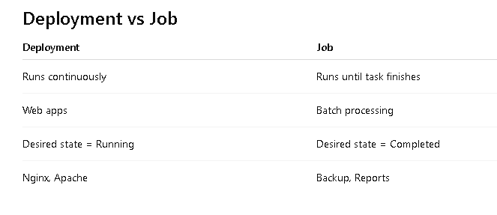

Real-Time Example
Suppose Flipkart generates a sales report every night.
Read Orders
↓
Calculate Revenue
↓
Generate CSV
↓
Upload to S3
↓
Exit
Once complete:
Pod Status = Completed
No need to keep the Pod running.
This is a Job.

